


YANGZHOU UNIVERSITY

Integrated Circuit CAD Design Report

Title: VLSI Design Flow of CMOS Adder Using lib7 Library in Cadence Virtuoso.

Student Name | Sifat Md Aminul Islam(西法特）
Student ID | 238801031
Major | Microelectronics Science And Engineering
Lecturer | 郭鹏飞
Date | 2026-07-02

Full IC Design Flow
Run the following command to start virtuoso:
Right click on the desktop and select open terminal; Type cd at the cursor on the terminal command line, and then click Enter，and then follow :
mkdir 238801031
cd 238801031
virtuoso &
This will open Cadence
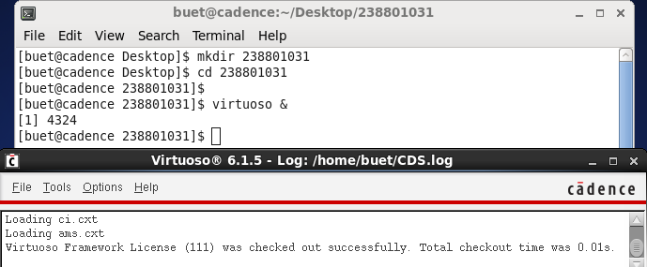

2. Creating a Schematic View
In Cadence, there is a relatively straightforward hierarchical organizational structure. Libraries (the furthest left column in the library manager) are collections of Cells, and Cells are collections of Views. The first thing that you will need is a new library. To do this, go to the CIW click File → New → Library. A new window will pop up. Type lib7 in the name field and press ok
At this point, Cadence will prompt you for something called a Technology File. The technology file is a library or group of libraries that all cell views inside of your new library will automatically reference. This basically means that you will not have to import models every time you run a new simulation.

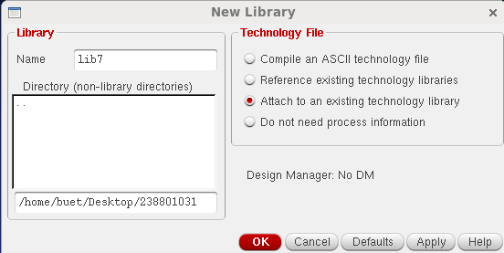

To import the technology file for this class, click the “Attach to an existing techfile” button, press ok, and use the drop down menu to select “gpdk090”. This stands for generic process design kit, 90nm refers to the minimum feature size available.
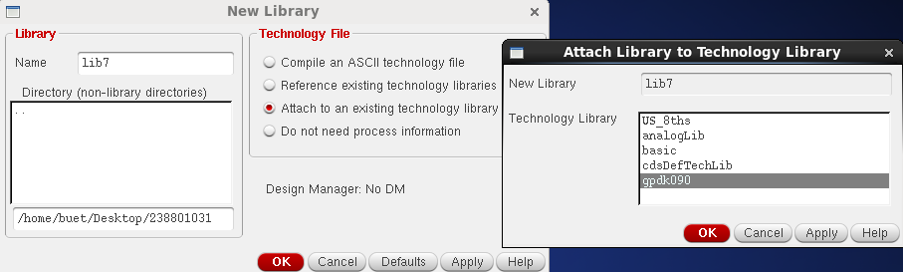

Now that you have a library, you can create your first schematic. In Virtuoso window click File → New → CellView. When prompted, name the new cell view sel and select “schematic” from the drop-down menu and "schematic" should auto-fill under View. Click OK, and the schematic editor should open up. Now we can build a virtual representation of our circuit at the transistor level.
To instantiate circuit elements in the schematic, press the ‘I’ key. This will bring up the Add Instance window and the Component Browser. In order to draw the schematic of sel, we need 1 inverter and 3 NAND gates which we have done previously in lib1 and lib2. To put all the required components into your schematic, go to Component Browser, change Library to lib1, tick the “Flatten” box, and scroll down to inv.
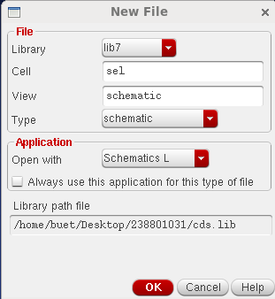

This selection should auto-fill in the Add Instance window. You can also type these references into the fields manually. After you choose your insurance Press the “hide” button or hit the Enter key in the Add Instance menu and click down the instance (inv or NAND) into your schematic. Press the ‘Esc’ key to stop adding components.
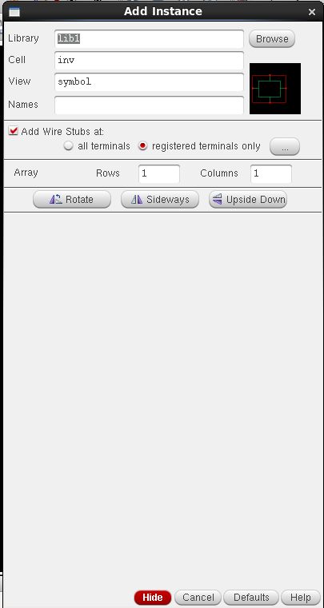
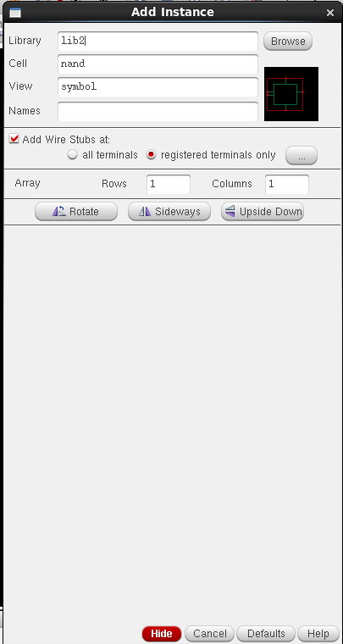

If you ever want to change a properties after placing it in the schematic, click on it and press the ‘q’ key. But for previously made components like inverter or NAND, you need to got to the library and change the variables manually and then the new schematic will be changed as well.
Now that all of our components are in the schematic, you will need to connect them together. Press the ‘w’ key to open up the “Add Wire” window. This will allow you to make connections between nodes. Simply click on the red squares (the contacts) in the schematic view, and make the connections needed for an sel circuit. Remember to connect the bulk terminals of the NMOS and PMOS devices to gnd and vdda respectively. You can use ‘s’ to snap the wire to the nearest contact, indicated by a diamond on the schematic.
To navigate the schematic, use the arrow keys on the keyboard to pan around. You can zoom in/out by clicking the magnifying glass buttons on the toolbar, or with the hotkeys control-Z/shift-Z. You can also zoom to a specific area by click-dragging a square with the right mouse button around the region of interest. If the circuit ever disappears, or if you want to take a look at the whole circuit, press the ‘f’ key. If you want to take a look at the whole circuit press the “f” key. The last thing you need is two pins to indicate the input and output of your sel. This way the cellview can interface with higher level schematic.
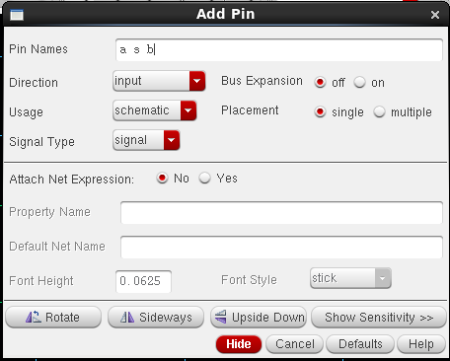
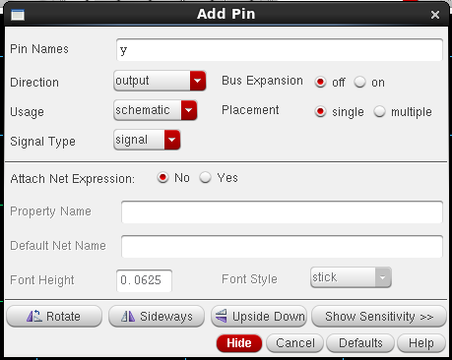

Press the ‘p’ key to open up the “Add Pins” window, type the names of your pins with spaces between them (I used a s b and y here, you can use whatever you like). Make sure that you select “input” in the direction drop-down menu for “a s b” Add pin windows, and “output” in the direction drop-down menu for “y” Add pin windows. click “Hide”, place your pins in the schematic, and wire them up.
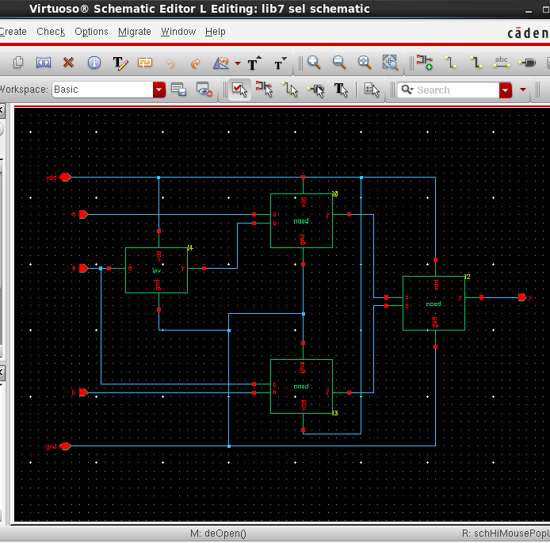
If you followed the instructions carefully, your schematic should look something like this:

When it does, press the “Check and Save” button (it looks like a box with a check mark). Leave the schematic editor open for now; we’ll need it for the later portions of the lab.
One more quick thing to note before you create a symbol. Sometimes it is useful to label nodes instead of directly connecting them with a wire. To connect two nodes, just label them with the same name! To create a label, press the ‘L’ key, type in the desired node name, and click on the wire in the schematic.

3. Creating a Symbol View
Now that your schematic is finished, we need create a symbol for it. Click Create → Cellview → From Cellview A pop to create symbol appears. After you press OK, a new pop-up title "Symbol Generation Options" shows up. Press OK here too.
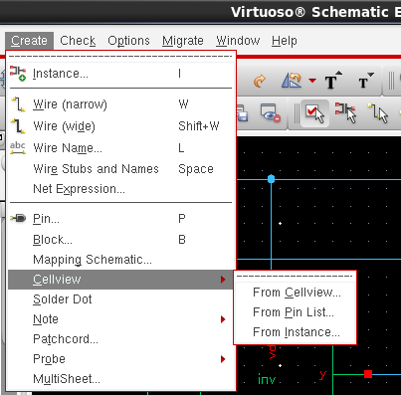
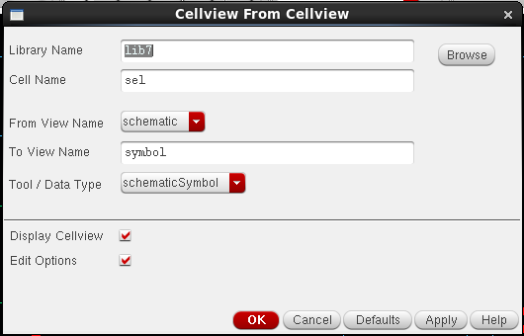

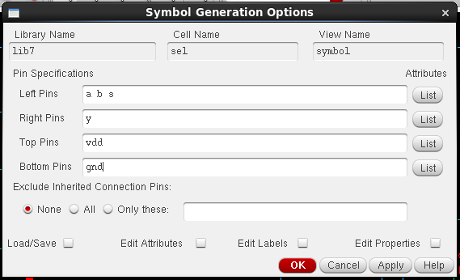

Notice that vdda and gnd do not show up here. As mentioned earlier, those are global pins that are shared throughout the design automatically.
After you press OK, you will have the opportunity to place the missing pins in the symbol editor. Click to place the pins, rotating by clicking the right mouse button if needed. Note that the red dot is the actual point where a wire will connect, so put it towards the edge of the symbol. Draw various shapes using the shape buttons at the top to make your symbol look like an actual sel. Save your symbol view when finished.

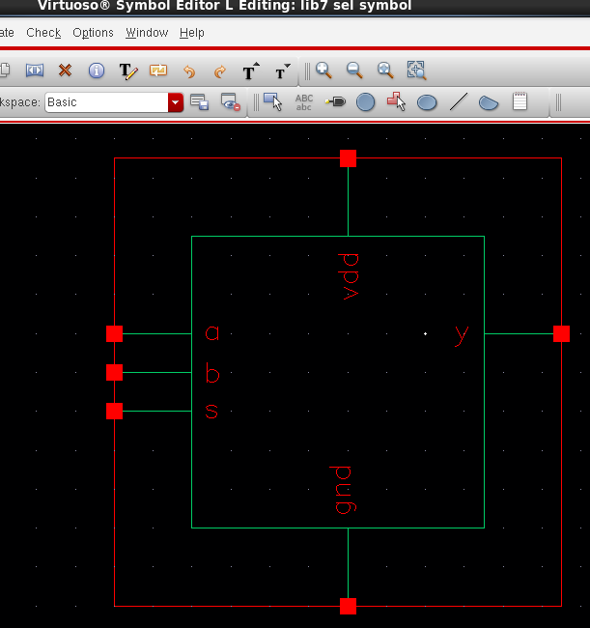

Creating a Layout View
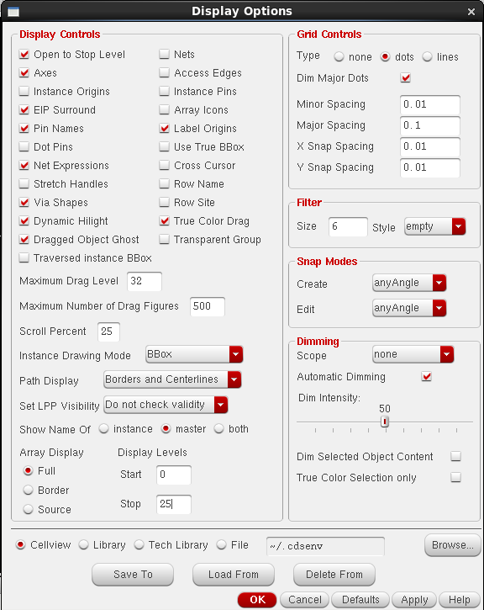
Go back to the CIW window and create a new sel cell view in lib1 library， as you did previously. This time, select the “layout” option as the tool. This will create an empty layout editing view. First, press the ‘e’ key to get to the display options menu. We will need to change the snap spacing so we can move our cursor with sufficient resolution. Make sure your grid matches 5nm requirement. A layout that does not comply grid will not pass DRC checks and will require re-layout. You can change display levels to stop at 25 so that we don’t run into any problems. As shown in the figure below.
Now press the ‘i' key to instantiate some transistors. Find the layout view of the INVERTER and NAND you drew in schematic, set the length and width to match, and place the devices in your layout.
To specify the material, such as “poly”,we can go to the “Layers” toolbox on the left side. Find “poly” and click on the layer whose purpose is drawing. Now press the ‘p’ key to create a path. A “create path” dialog box should pop up; if it doesn’t, hit ‘F3’ on your keyboard. Change the path width. Click once to start a path, double click to end a path. Draw a 0.10 micron “Poly” trace to connect the transistor gates together.
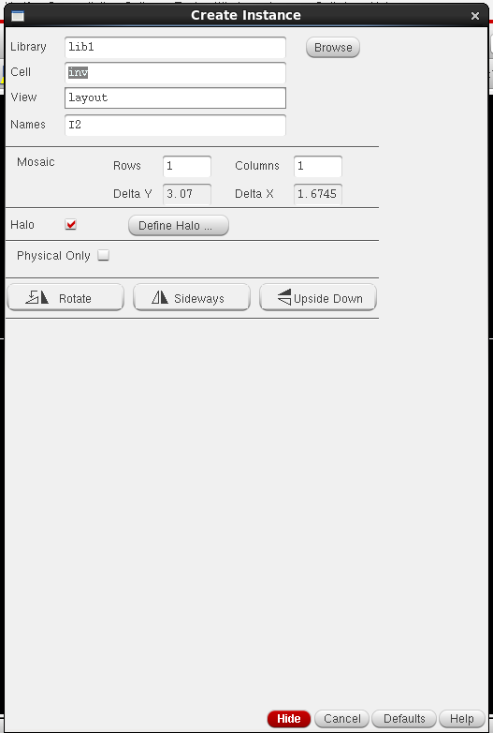
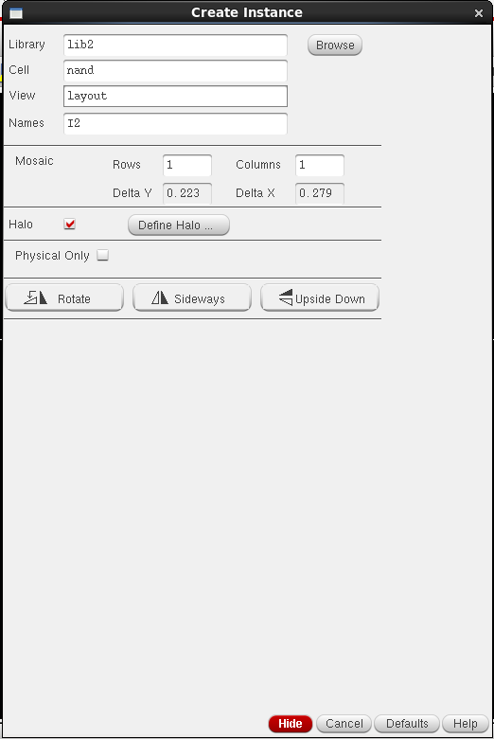

This may be the first time you’ve seen a MOSFET laid out! Figure out what the different layers mean. Where are the source, gate, and drain? Where is the channel?
Polysilicon is quite resistive; we’d want to switch to metal traces as soon as possible. To do this, there needs to be a via between polysilicon and metal lines. To do this, go to the menu and click Create → Via. Make sure the “via definition” is “M2_PO”. Rotate it and place it onto the layout. After you’ve finished the steps, your layout should look like this:
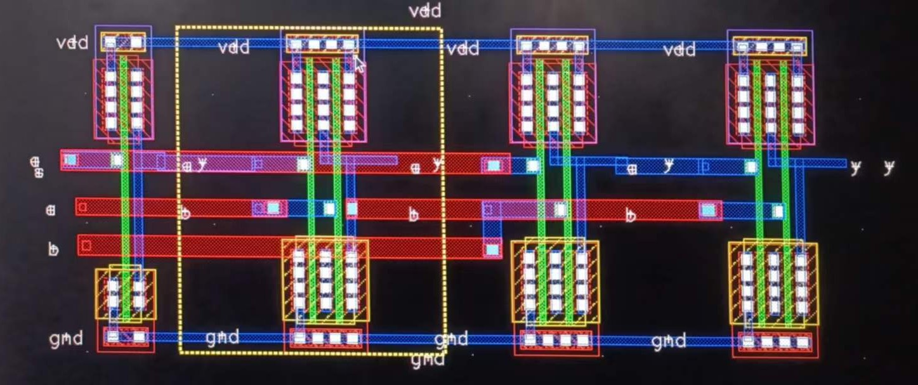

5. Adding Pins to the Layout View
Remember that, in the schematic and symbol, we had pins for the input and output of the sel. Select the “Metal1” layer, then on the menu bar, click Create → Pin. Type “a s b” for the terminal names and setting should look like follow picture, then type “y” for the terminal names and setting should look like following next picture.
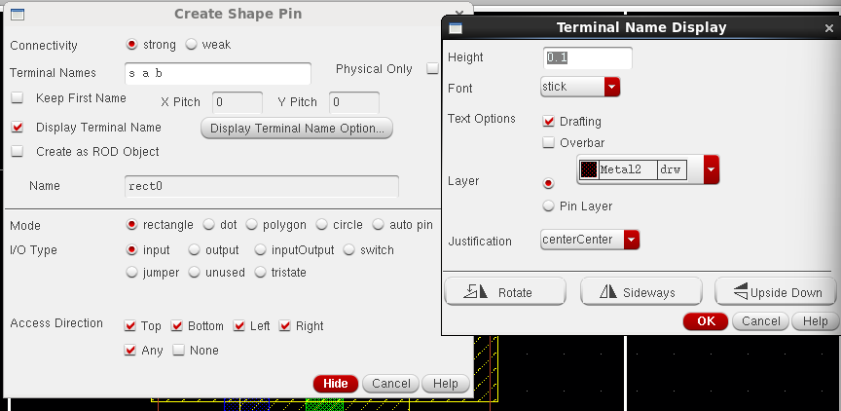

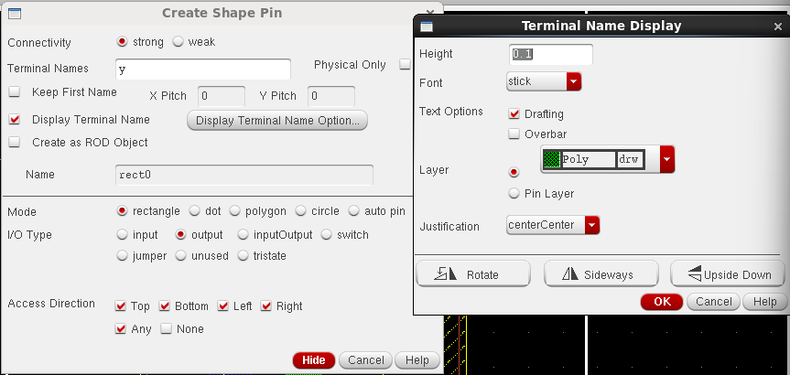

Now you can draw two metal squares onto the input and output of the sel.
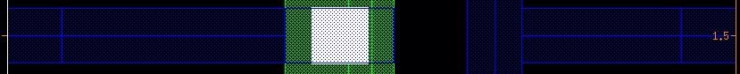

We also need to label the pins and global nodes. Press the ‘l’ key to create labels. In the text box, type in “vdda! gnd!”, change the height to 0.08, and change the layer to Metal1. Now you can label the terminals.
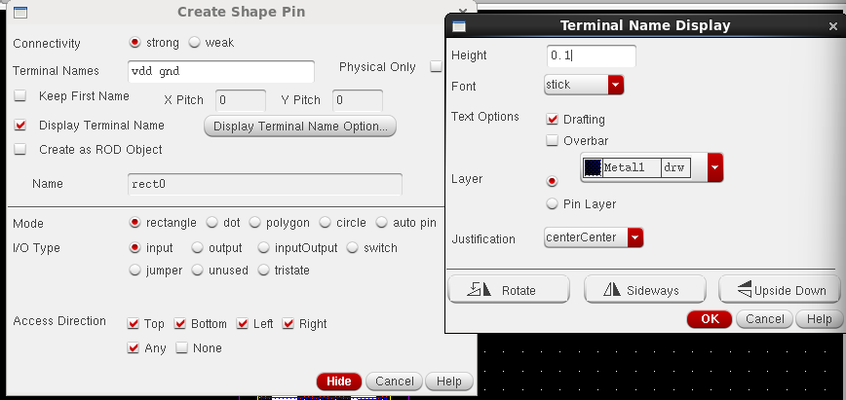

6. Design Rule Checking (DRC)
The DRC checker verifies that your drawn layers obey all of the design rules. These design rules are provided by the IC foundry to ensure that the IC devices perform to specification. The design rules document can be found in gpdk090 pdk.
From the Virtuoso layout menu bar, click Assura → Technology. In the
“Assura Technology File” dialog box, enter the following:
/home/buet/cadence/gpdk090_v4.6/assura_tech.lib
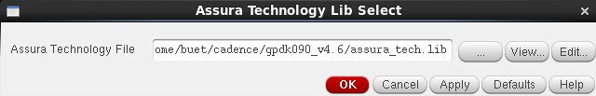

Click OK. In the Virtuoso menu bar, click Assura → Run DRC. Switch the “Technology” option to “gpdk090”. Your “Run Assura DRC” menu should look like this:
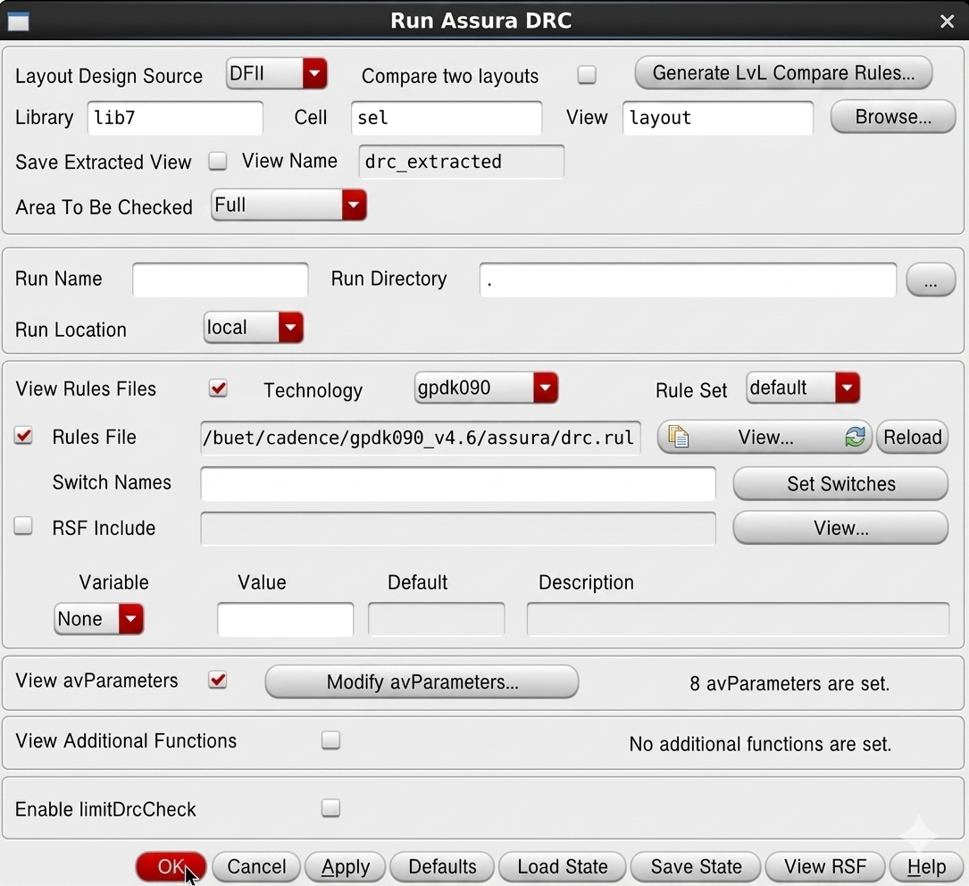

Now click OK to run the DRC checker! The results should be displayed in the Virtuoso window. You’ll probably have some problems – the errors may be really difficult to understand. Try to decode what needs to be fixed (usually has to do with spacing between components and paths not flush with each other). Ask your GSI if you’re stuck. When there are no errors, your Virtuoso window should look like this:

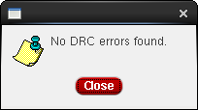

- Layout versus Schematic Verification (LVS)
Now, we need to check to see whether the transistors we placed here actually match up with the transistors we placed in schematic. To do this, we run a layout vs. schematic (LVS) checker.
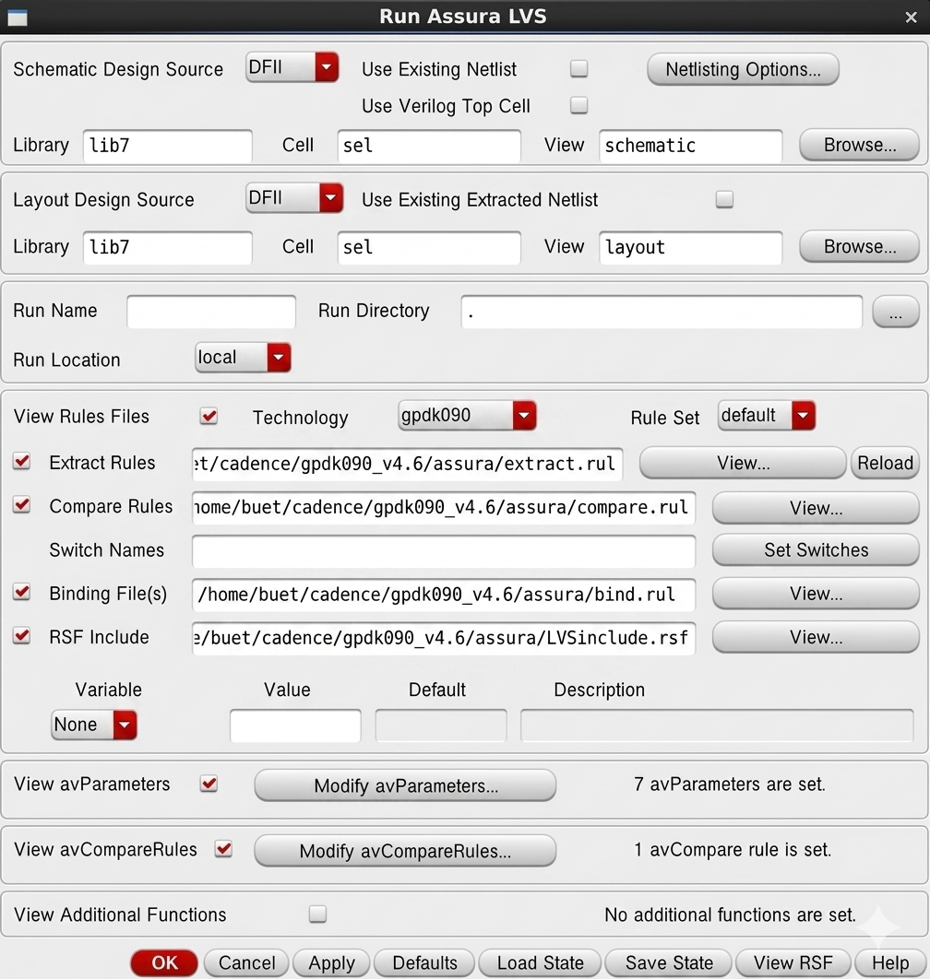
Click OK. In the Virtuoso menu bar, click Assura → Run LVS. Switch the “Technology” option to “gpdk090”. Your “Run Assura LVS” menu should look like this:

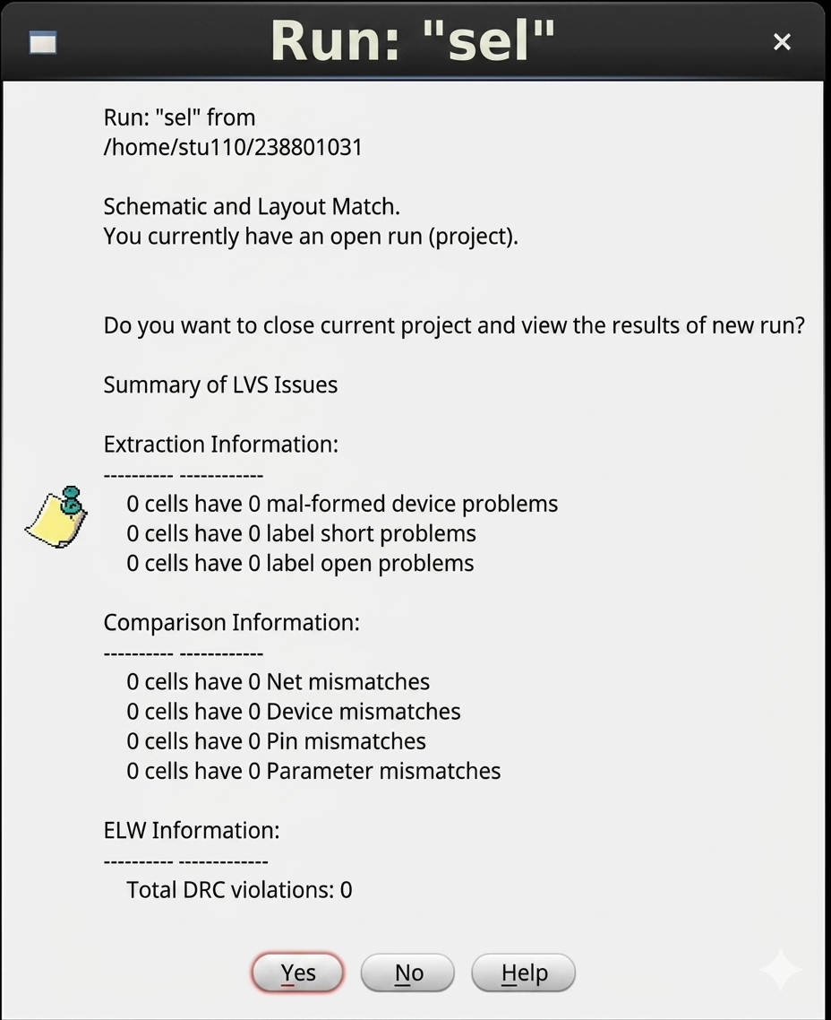
Click OK to run LVS. If your layout matches your schematic, you will see the following message:

If you have any LVS errors, please correct them by making the appropriate adjustments to your layout. Remember to run DRC check again to verify that the update doesn’t violate any design rules.
At this point, your layout now passes DRC and LVS – a huge milestone in the IC design process. Next, we will examine how the physical placement of transistors (layout) impacts circuit performance.

Parasitic Extraction with Assura (QRC)
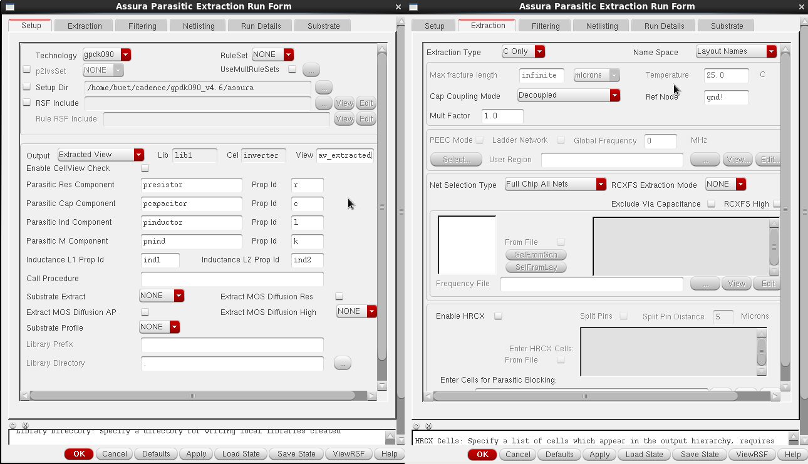
This tool allows us to extract parasitic resistances and capacitances from the layout view. Now, click Assura →Run RCX. Adjust the settings in the setup, extraction, and netlisting tabs to match the screenshots below.
sel

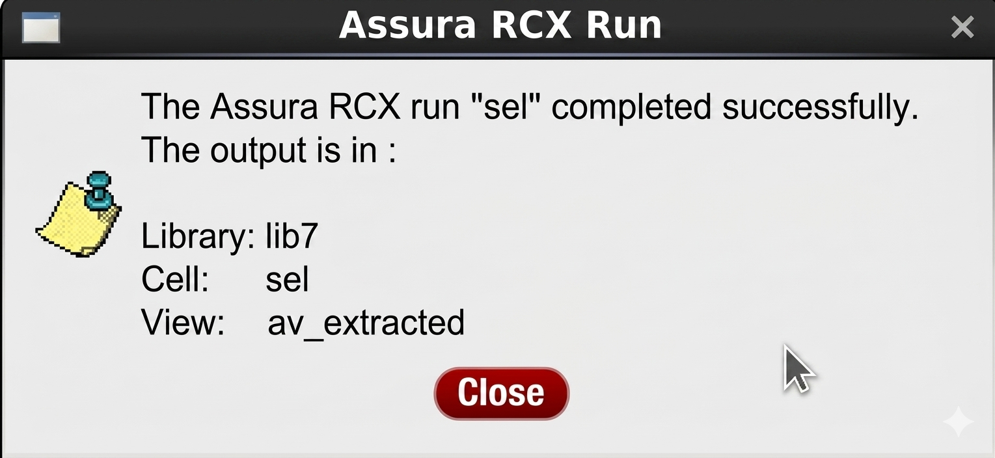
Make sure you have entered gnd! as the REF node. Else the extraction will result in dangling nodes. Click OK to run the parasitic extractor. A successful extraction should give you this message:

Return to the library manager, and your sel cell should have a new view named “av_extracted”. You can zoom in and see all the little parasitics! The extracted view looks something like below:

Once you zoom-in you will find tiny capacitors as below:

